**Lesson 04 Demo 04**

**Generating an** **Attention Insight Using Figma**

**Objective:** To create and analyze heat maps and CTAs for grocery e-commerce platform pages to enhance UI design using Figma

**Tools required:** Figma

**Prerequisites:** NA

Steps to be followed:

1. Create pages in Figma and load images
2. Utilize Figma to generate attention insights for grocery products

**Note:** Download the provided image files, **Product.png** and **Profile.png**, and store them on your local drive.

**Note:** Generative AI tool used in this exercise can produce varied outputs even when presented with similar prompts. Thus, you may get different output for the same prompt.

**Step 1: Create pages in Figma and load images**

* 1. Navigate to **Figma** website using the following link**:**

**https://www.figma.com/community/plugin/968765016617421513/attention-insight**

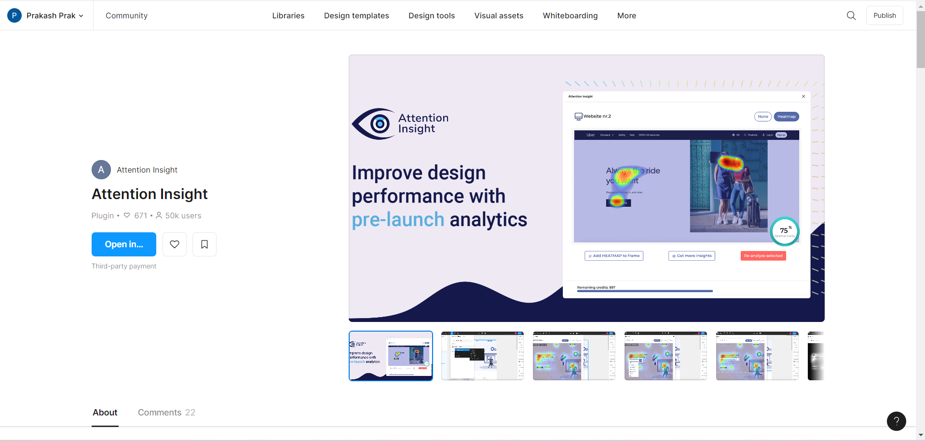

* 1. Click on **Open In** and then select **Figma basics**

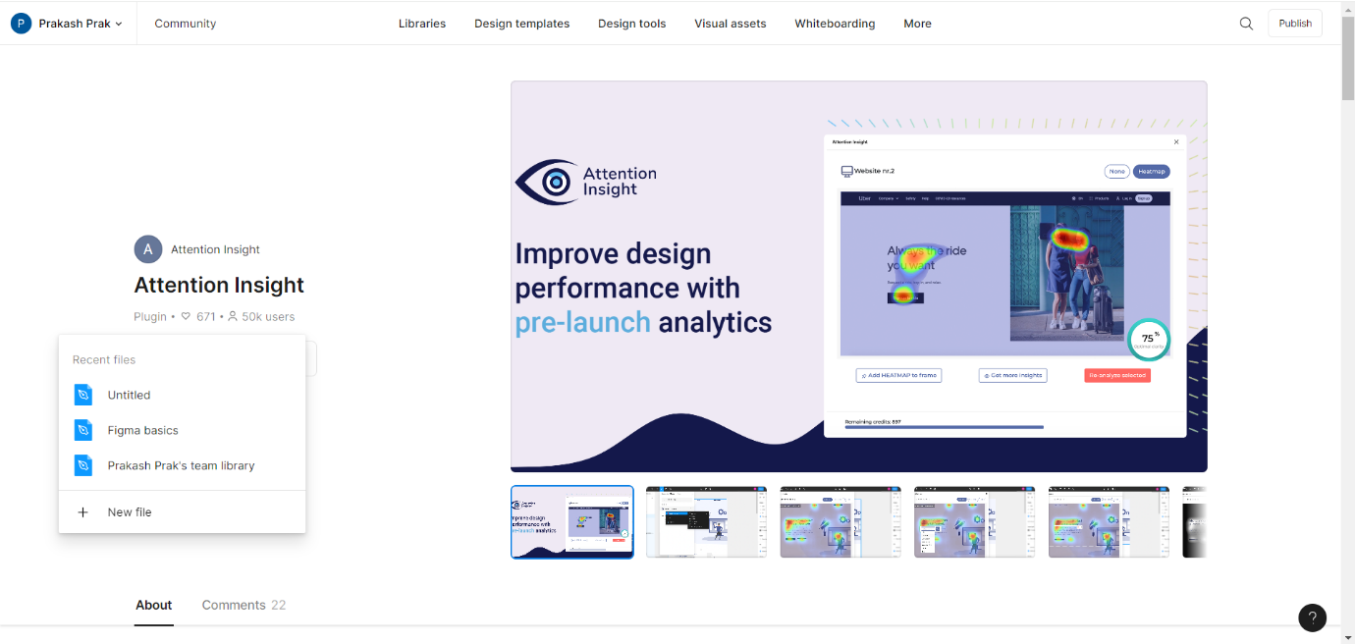

The Figma dashboard appears as follows:

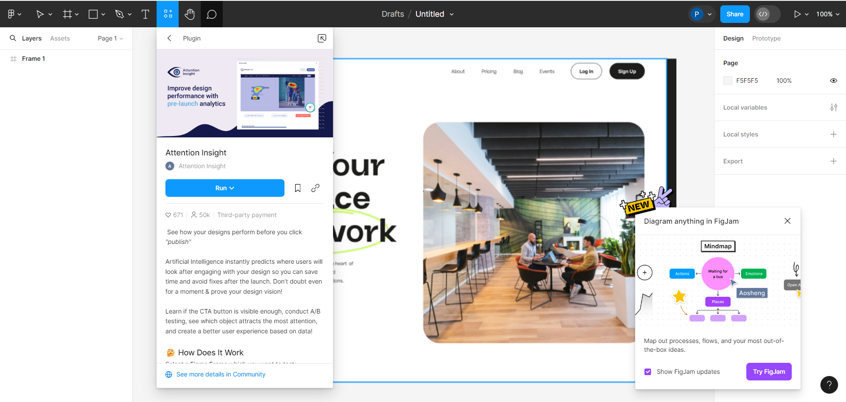

* 1. Navigate to the **Main Menu** at the top left, click on **File,** and select **New design file**

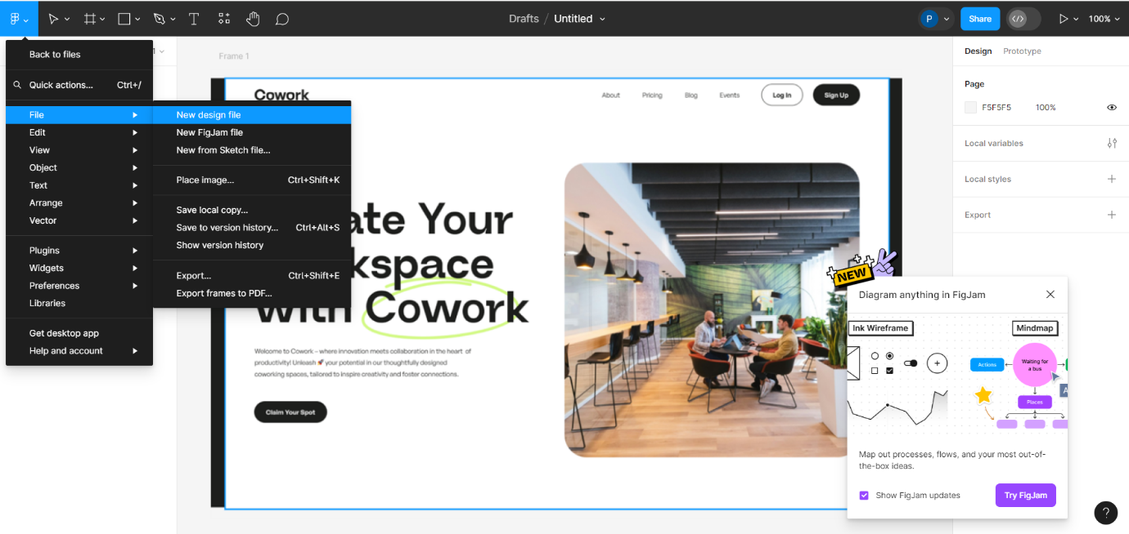

* 1. Open the new design file and name it as **ecommerce_app**

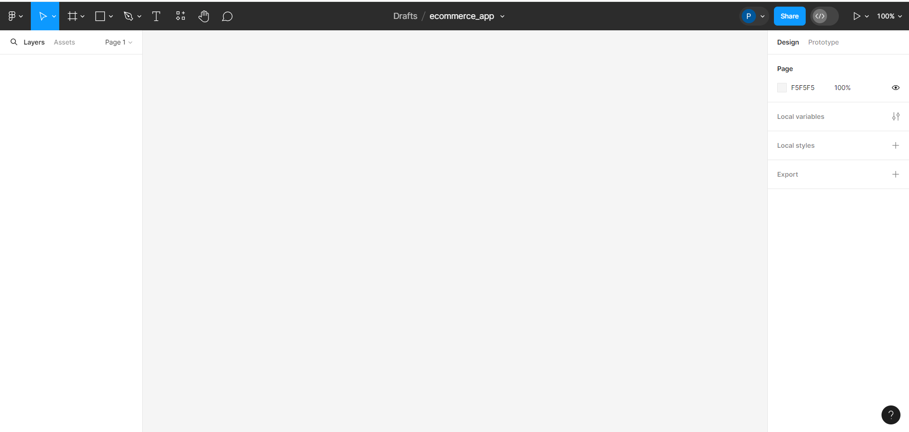

* 1. Create two pages by clicking on the **+** icon, one for **Product Search** and another for **Profile**

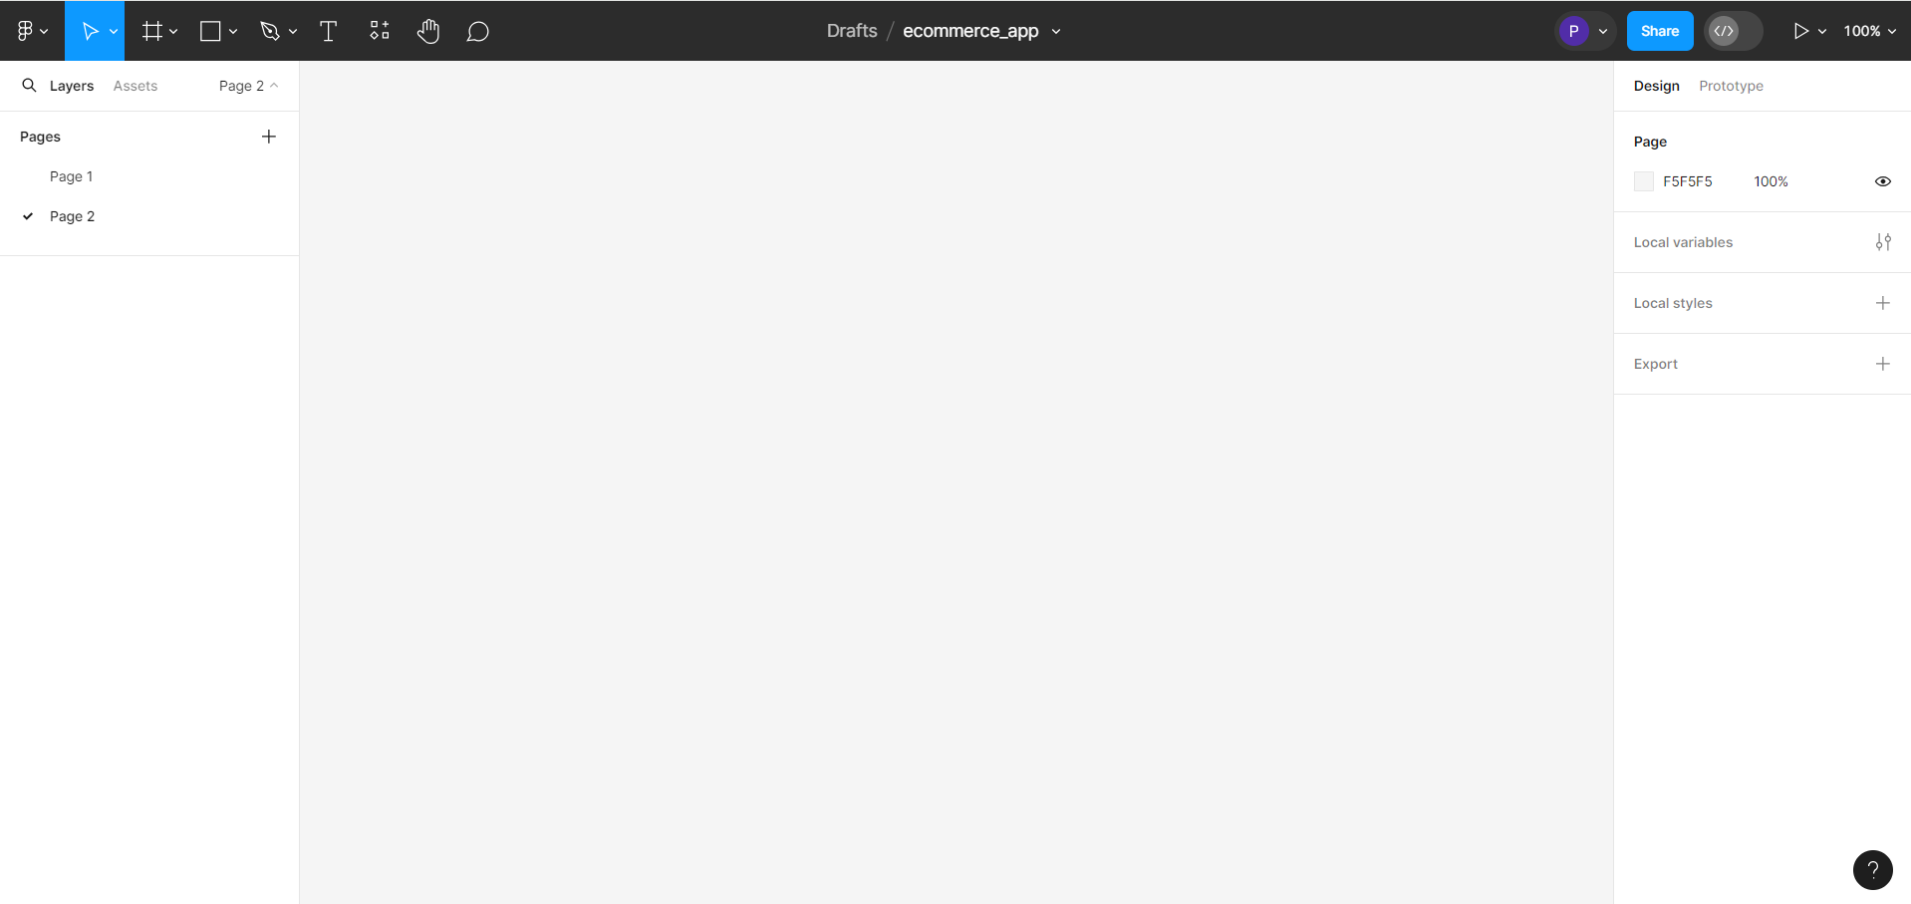

* 1. Drag and drop the **Product.png** image file from your local drive onto **Page 1**

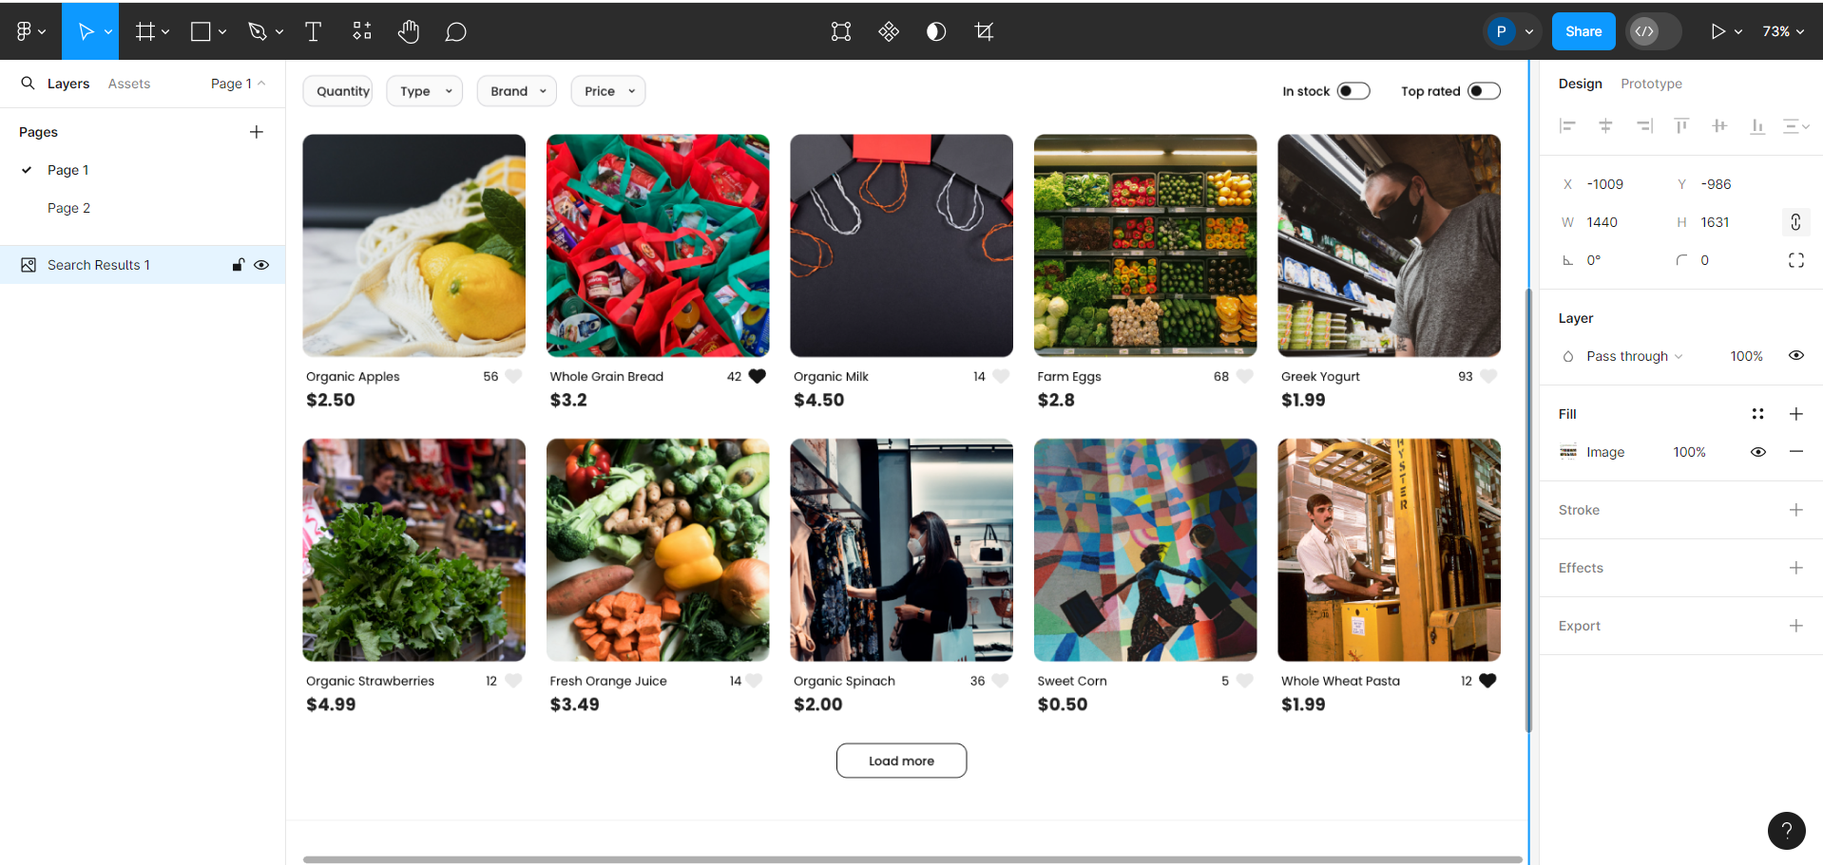

* 1. Drag and drop the **Profile.png** image file from your local drive onto **Page 2**

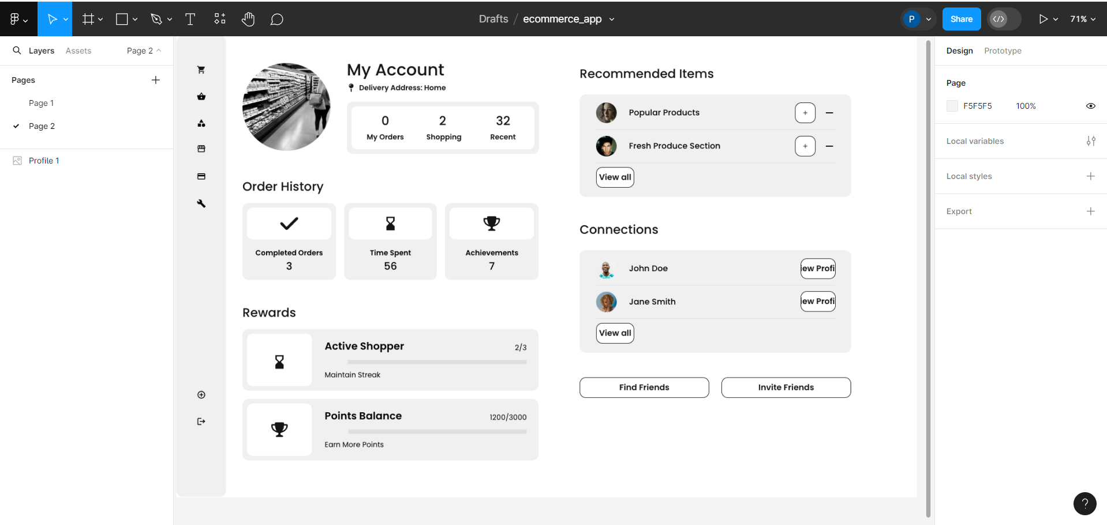

* 1. Rename **Page 1** as **Product Search** and **Page 2** as **Profile**

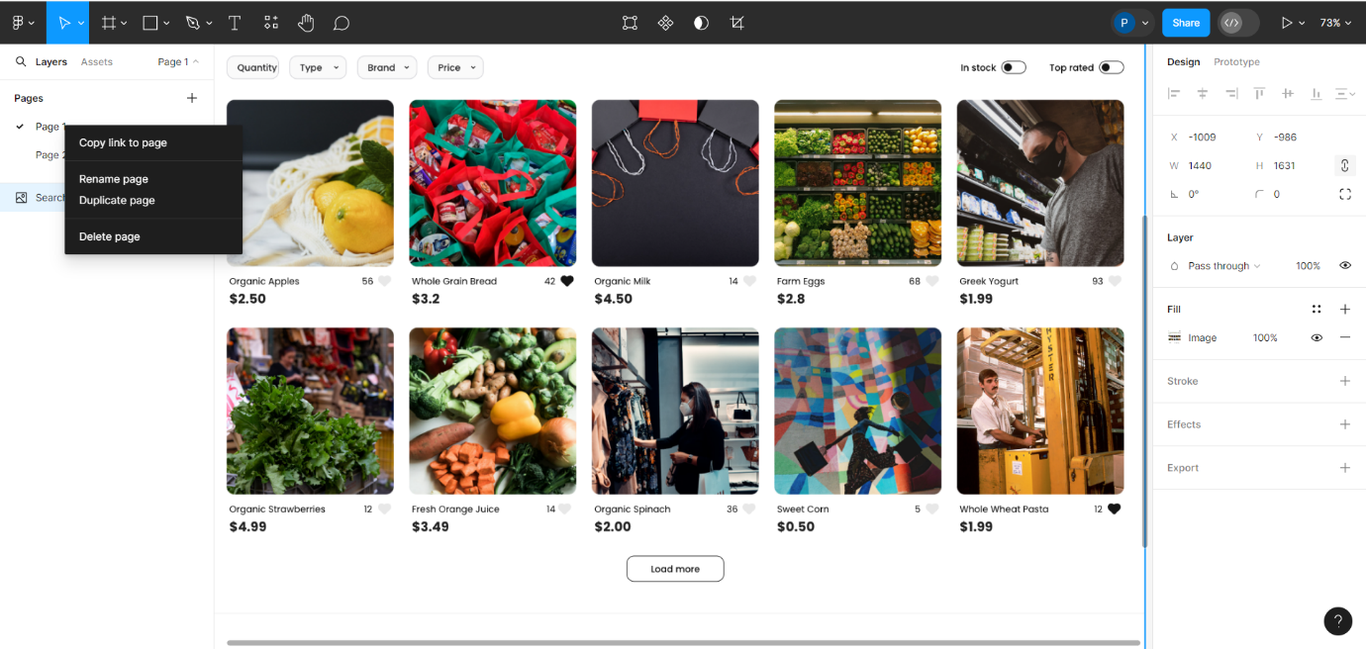

**Step 2: Utilize Figma to generate attention insight for grocery products**

* 1. Navigate to the **Product Search**, right-click on the image, and then select **Frame selection**

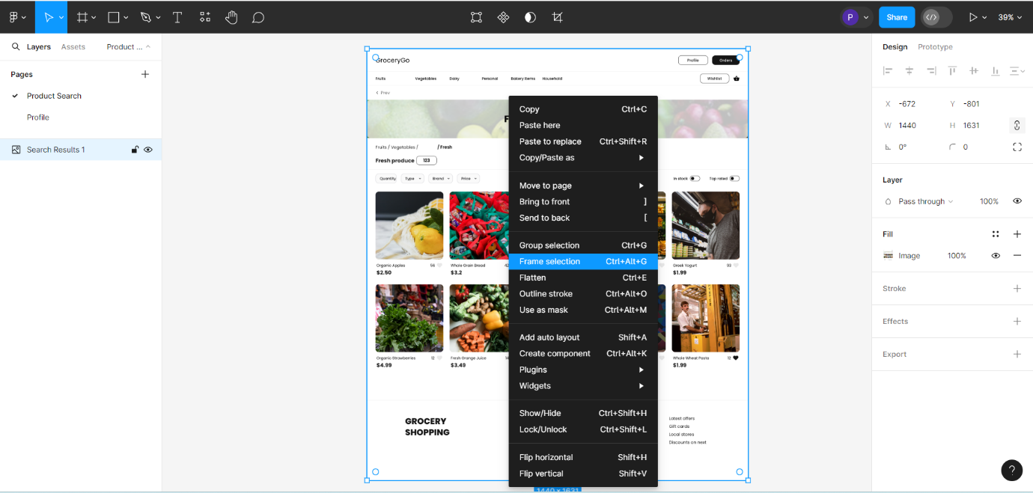

You will see the following interface:

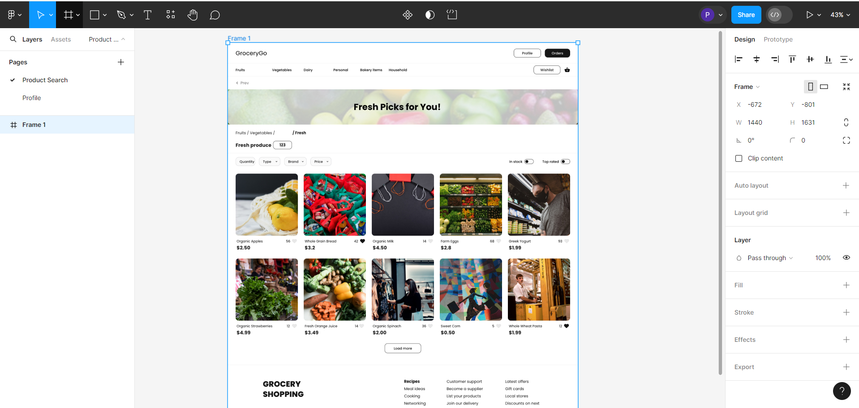

* 1. Create attention insights by following these steps. As it is for e-commerce, navigate to the **E-commerce** option as follows:

**Plugins -> Attention Insight -> Analyze Design -> Desktop -> E-commerce**

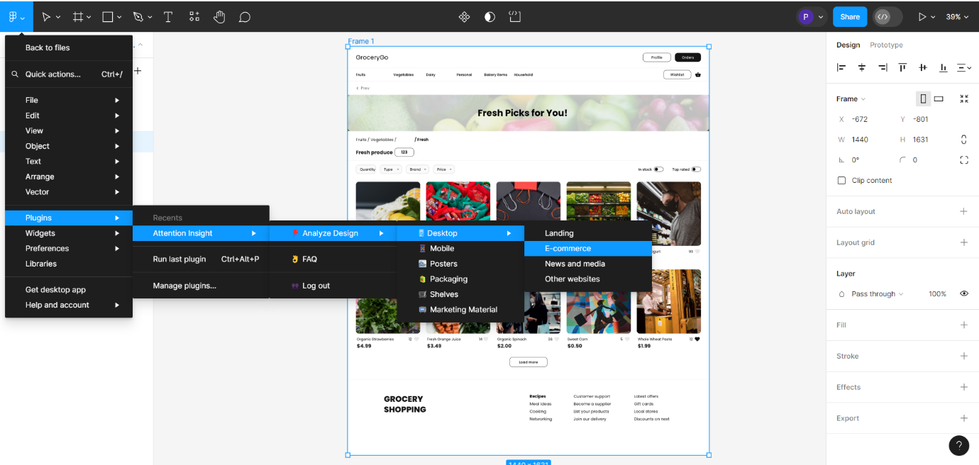

* 1. Re-log in to Figma when prompted to use **Attention Insight**

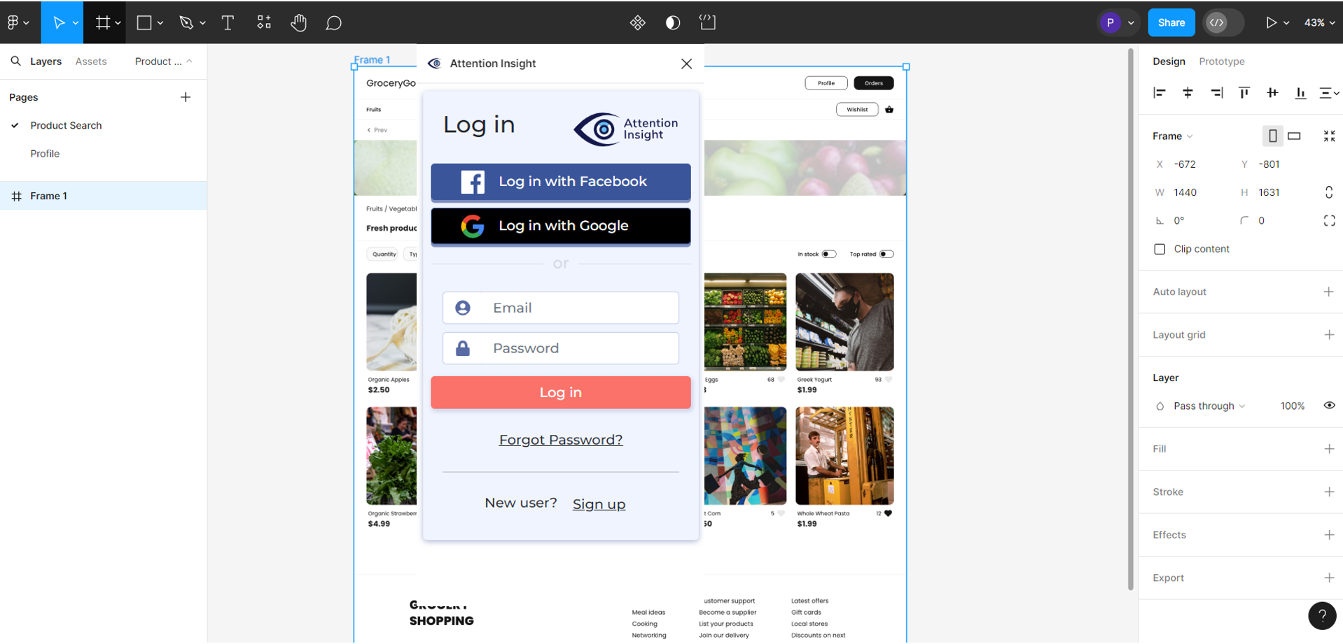

When the login is successful, it starts generating the output.

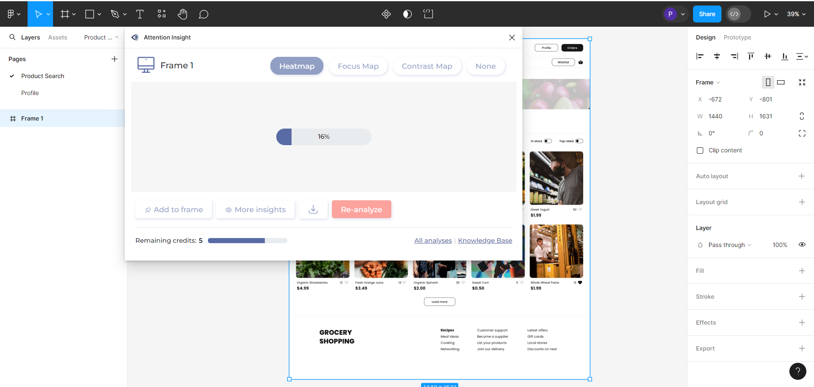

The heatmap for the **Product Search** page is as follows:

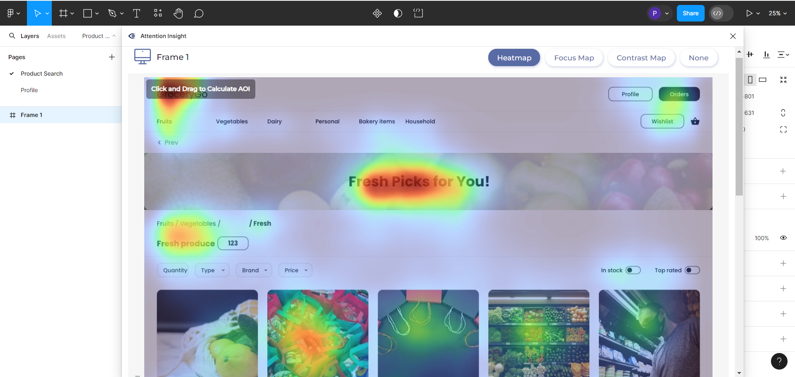

* 1. Calculate Areas of Interest (AOI) by selecting the desired area within the frame. After selecting, you may provide an optional name and click on **Calc**.

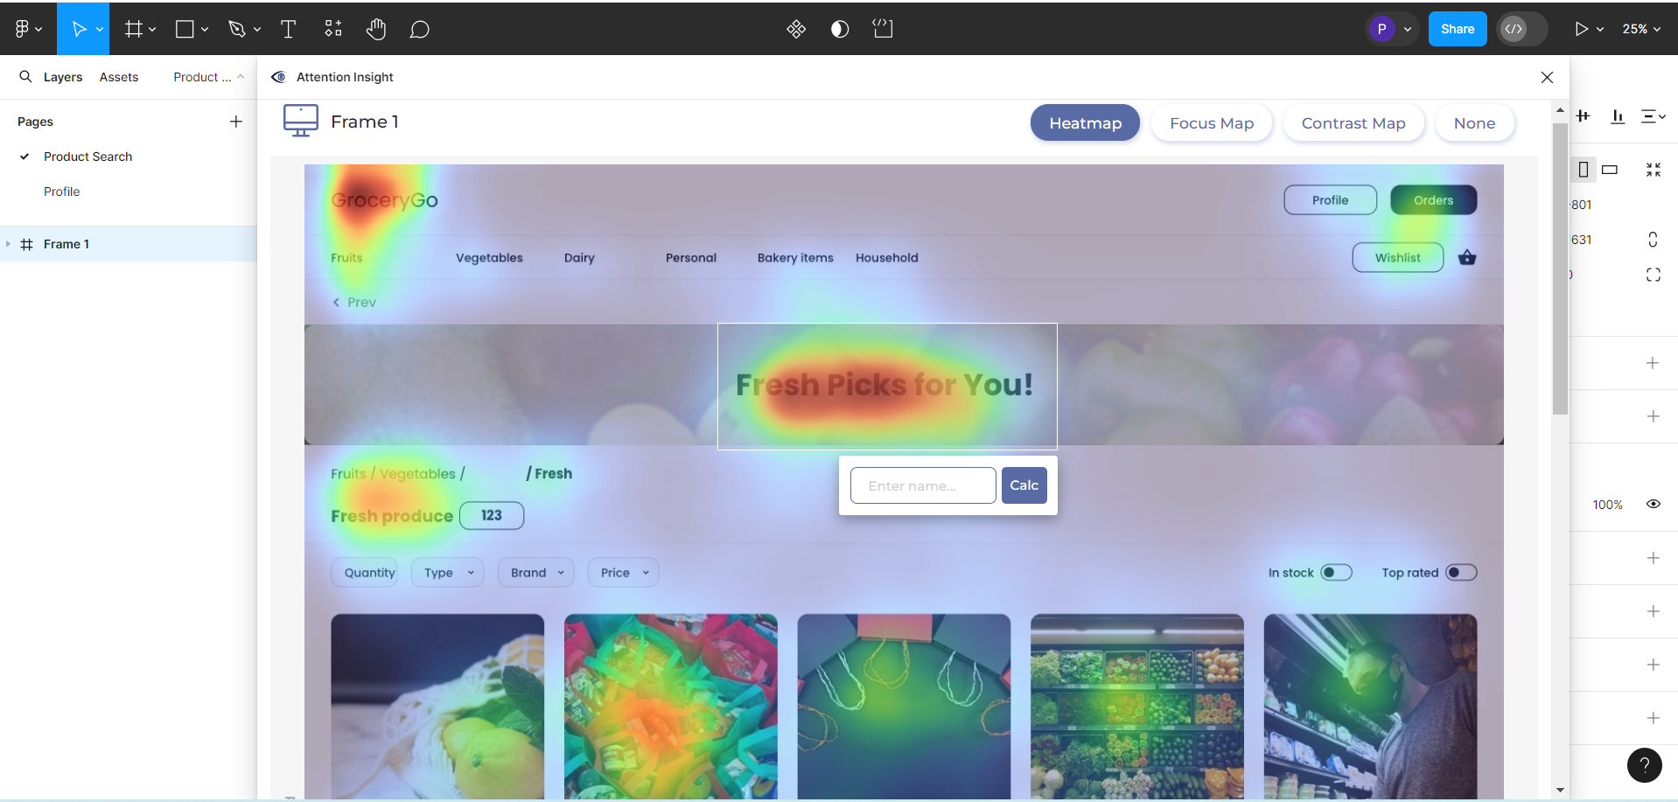

It will generate the percentage contribution of an area for call-to-action (CTA) and effectiveness. Below are the AOI percentage values of different areas:

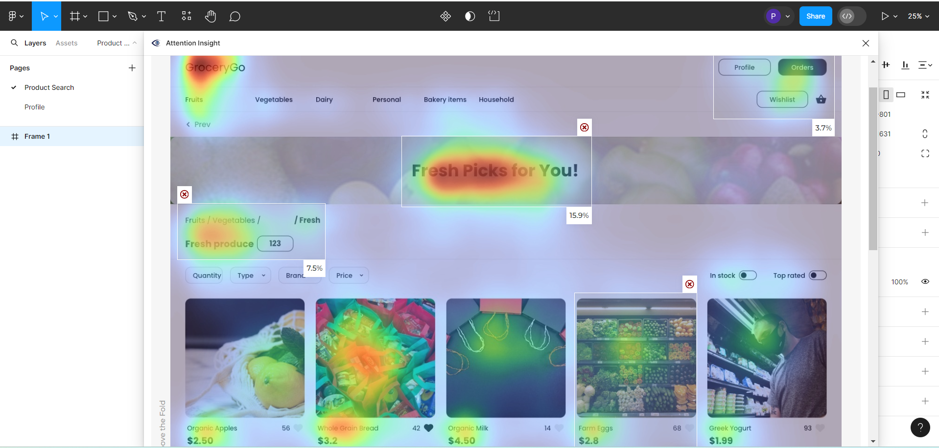

The values shown in the image estimate the amount of attention users are expected to give to each highlighted area of the user interface. Using these insights, the design team can enhance the visuals and overall layout to foster more engaging user interactions.

* 1. Click on **Focus Map** to visually analyze the parts that capture attention in the first few seconds

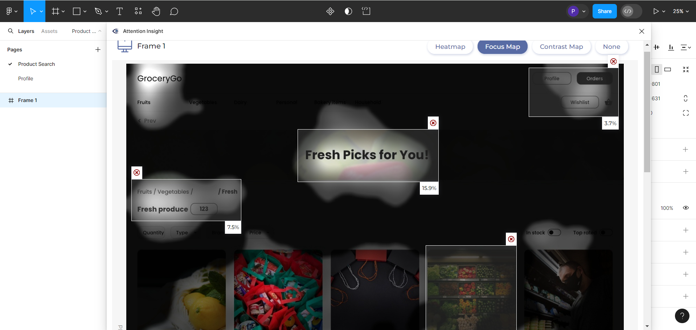

This helps in understanding the focus areas of the page to improve the overall design and fonts.

This insight enables designers to optimize the layout, content placement, and visual hierarchy to enhance user engagement and communication effectiveness.

* 1. Select **Contrast Map** to generate a numerical grid that shows the visibility and effectiveness of colors used in the surroundings

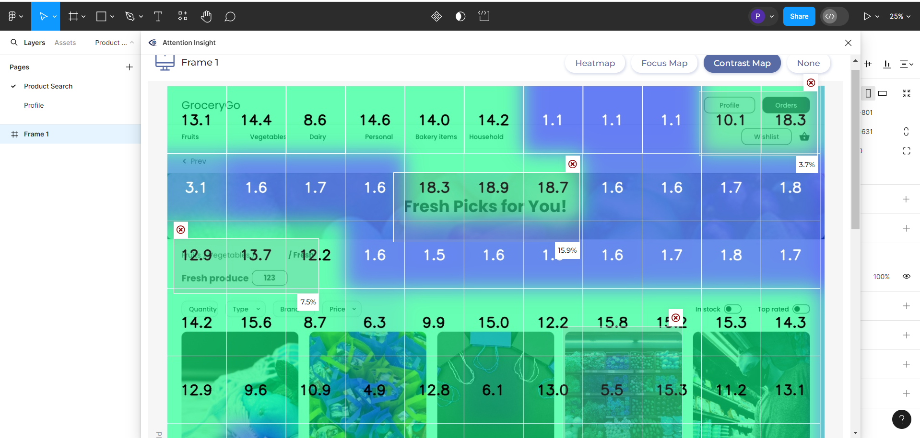

Areas with higher contrast ratios are indicated in green, while lower contrast ratios appear in blue. For objects crucial to your design goals, check if they are in the green zones of the Contrast Map to ensure optimal visibility; if not, consider enhancing their contrast.

* 1. Select the **Profile** page to perform the same process

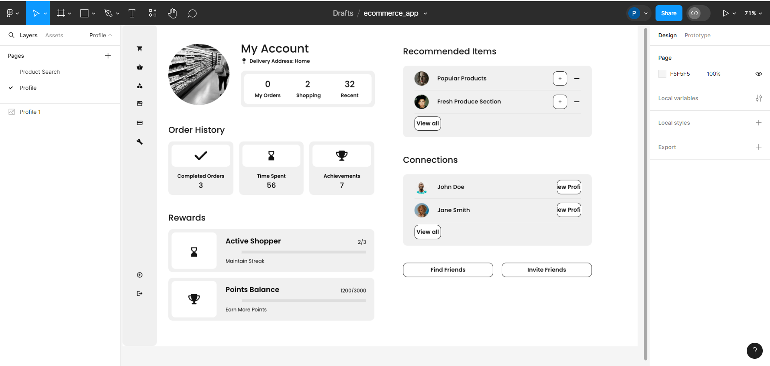

* 1. Select **Frame selection** by right-clicking on the page

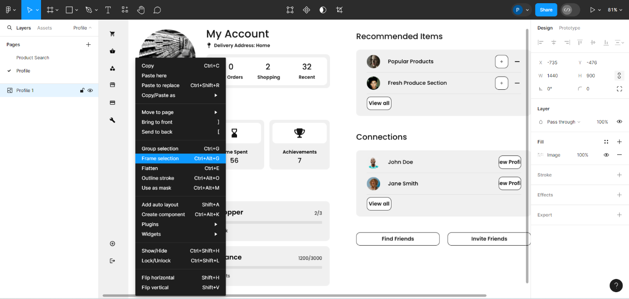

* 1. Navigate to the **E-commerce** menu from the main menu by following these steps:

**Plugins -> Attention Insight -> Analyze Design -> Desktop -> E-commerce**

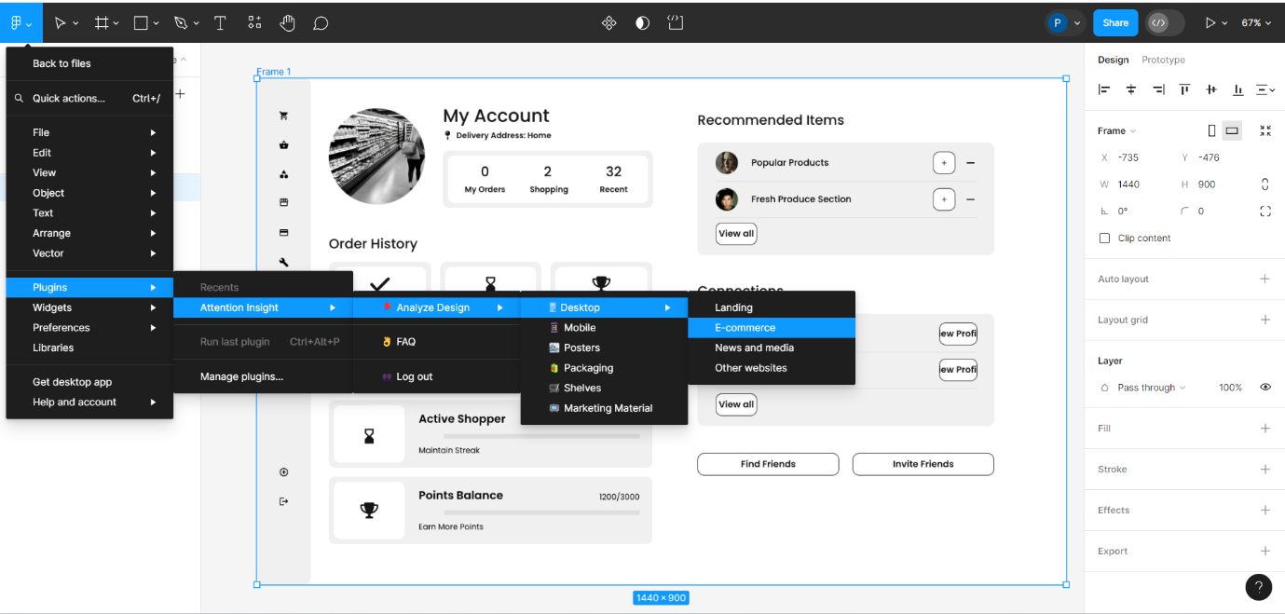

The attention insight generation progress for the **Profile** page looks as follows:

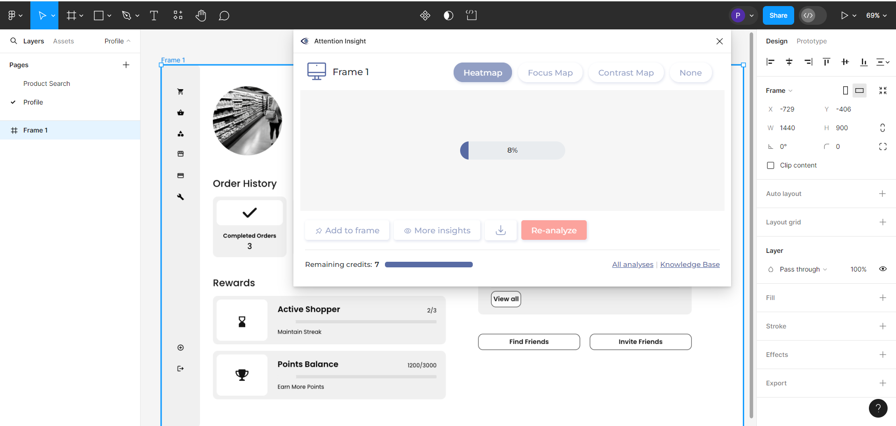

The attention insight for the **Profile** page is generated. The heatmap for the **Profile** page looks as follows:

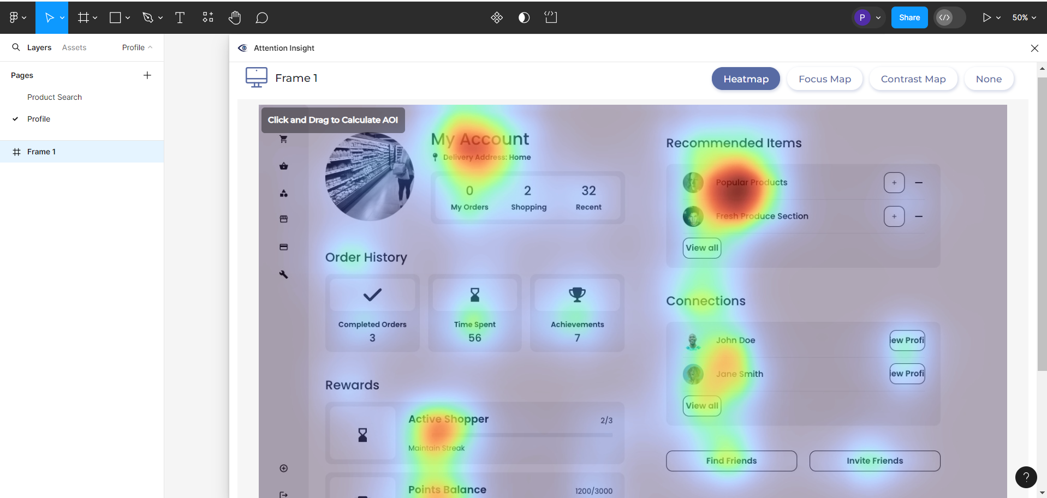

* 1. Calculate Areas of Interest (AOI) by selecting the desired area within the frame. After selecting, you may provide an optional name and click on **Calc**

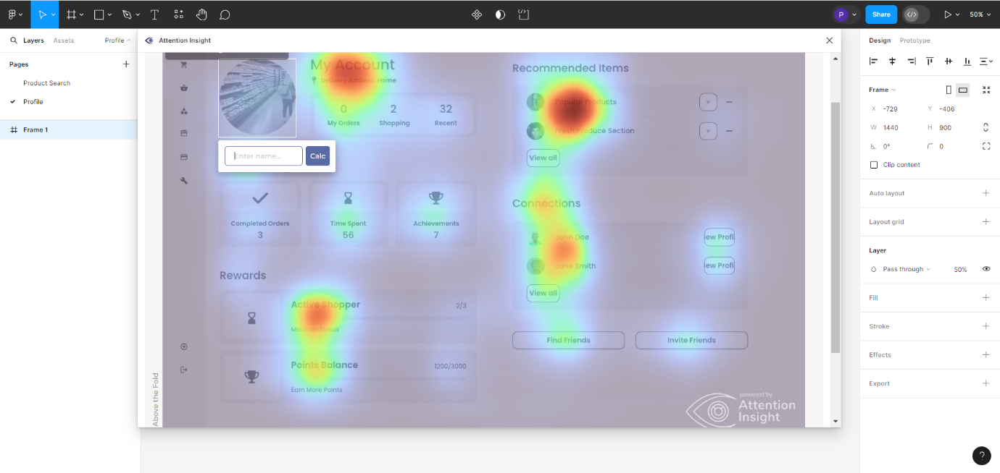

It will generate the percentage contribution of an area for call-to-action (CTA) and effectiveness. AOI percentage values of different areas are as shown:

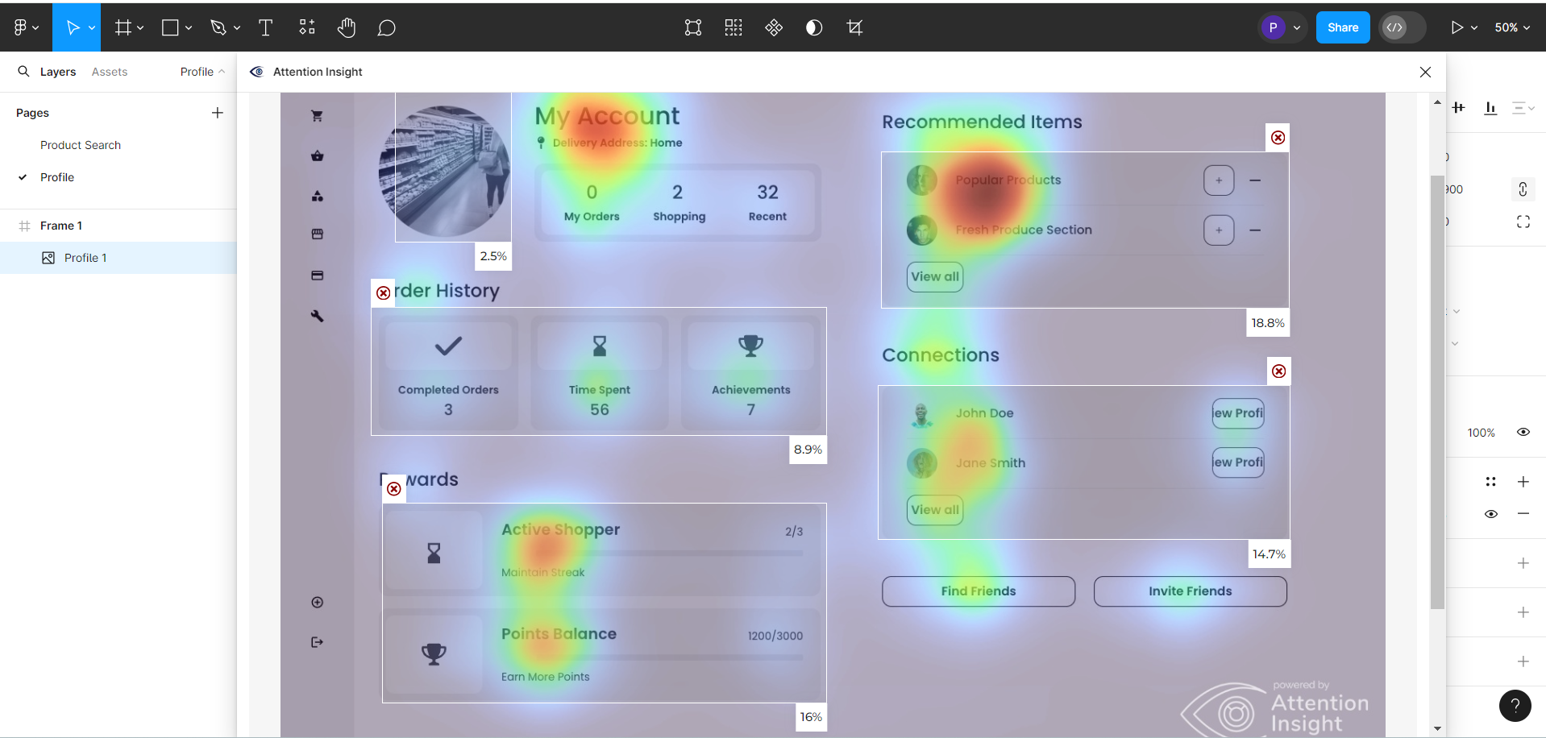

* 1. Click on **Focus Map** to visually analyze the parts that capture attention in the first few seconds

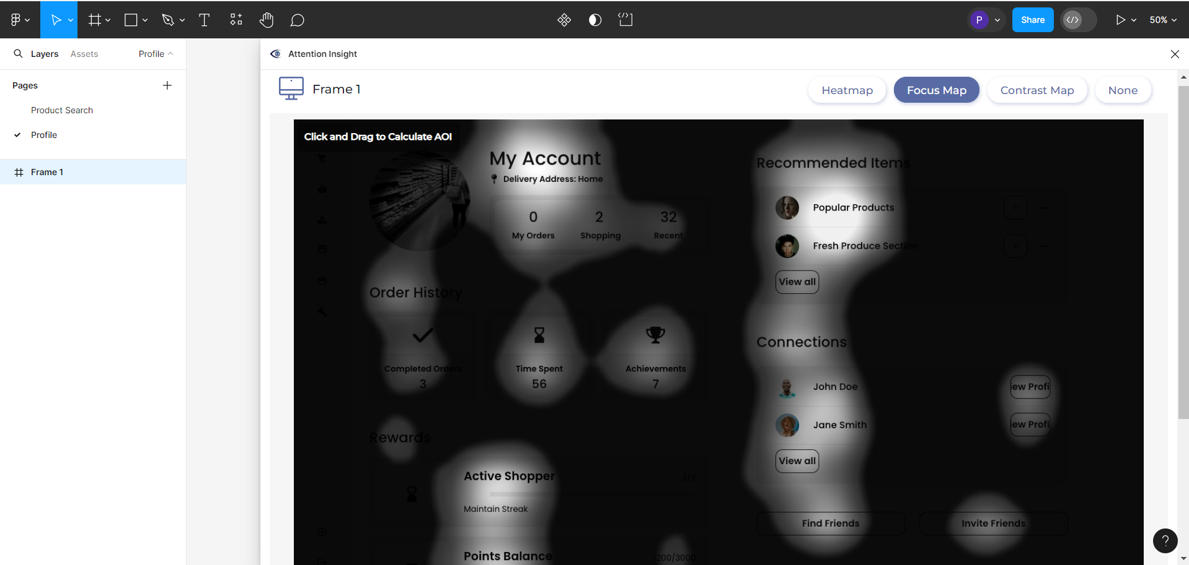

This helps in understanding the focus areas of the page to improve the overall design and fonts.

* 1. Select **Contrast Map** to generate the whole numerical grid of visibility and effectiveness of colors used in surroundings

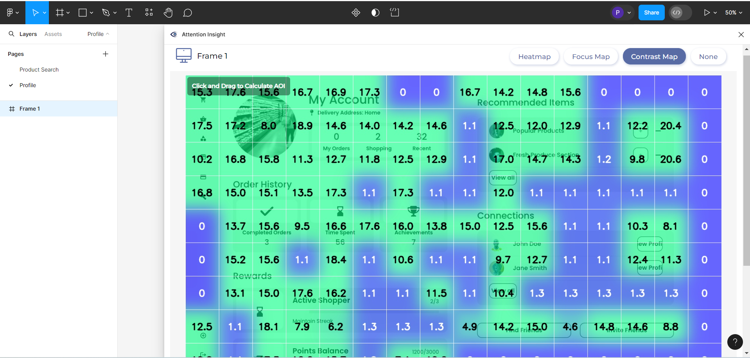

By following these steps, you have successfully utilized Figma’s Attention Insight plugin to generate maps, calculate AOIs, and analyze CTA contributions for an   
e-commerce platform. This process aids software development engineers (SDEs) or designers in enhancing UI design.